

Department of Electrical and Computer Engineering

ENCS3320-Computer Networks

Project#1

Group:

Hanna Hinn 1190336

MOhammad Halhuli 1191413

Noor Aldeen Tirhi 1190081

Instructor: Imad Tartir

Section: #3

# Table of Content:

Table of Content:

Part1:

Ping a device in the same network.

Ping www.youtube.com

Tracert ww.youtube.com

Nslookup www.youtube.com

Part 2:

# Part1:

## Ping a device in the same network.

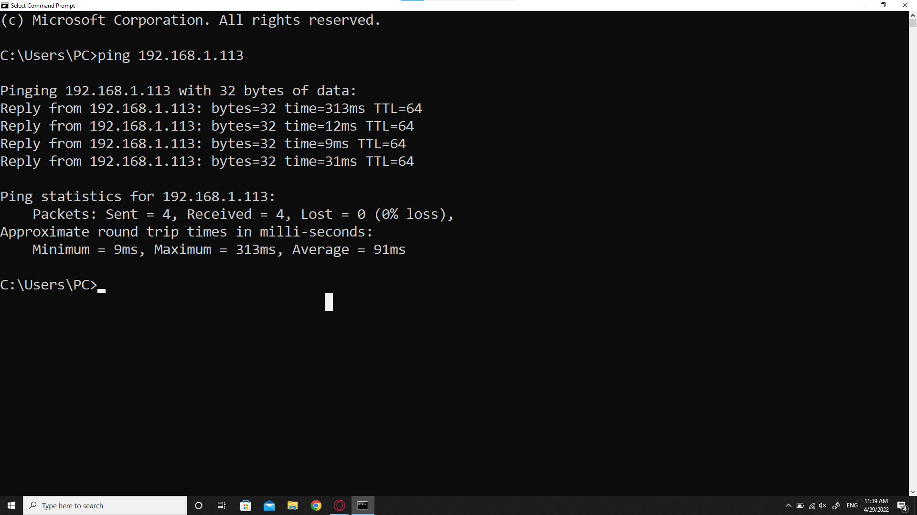

The ping command is used to verify IP-level connectivity to another TCP/IP device by sending Internet Control Message Protocol (ICMP) echo Request messages. If the request did not counter any troubles on its way, a receipt of corresponding echo Reply messages are displayed, along with round-trip times.

The ping command is used to troubleshoot connectivity, reachability, and name resolution.

In our example we pinged one of our mobile devices in the same network with the IP 192.168.1.113 from our laptop. First, our laptop has sent a 32 byte of data to our mobile, typically its 32 bits. The next four lines indicate the replays from the mobile to the laptop showing the amount of data that was sent back and response time and the TTL “time to live”. This information shows the total hops the packet will travel through before stopping. Where TTL=64 means that 64 hops the packet can travel before it is dropped, in this case it's normally 64. If we see “request timed out” that means that the packets could not find the host, which indicates a connection problem.

Then it displays a statistics summary for the whole process where our computer sent 4 packets and 4 packets were sent back from the device with an average round trip of 91ms.

## Ping [www.youtube.com](http://www.youtube.com)

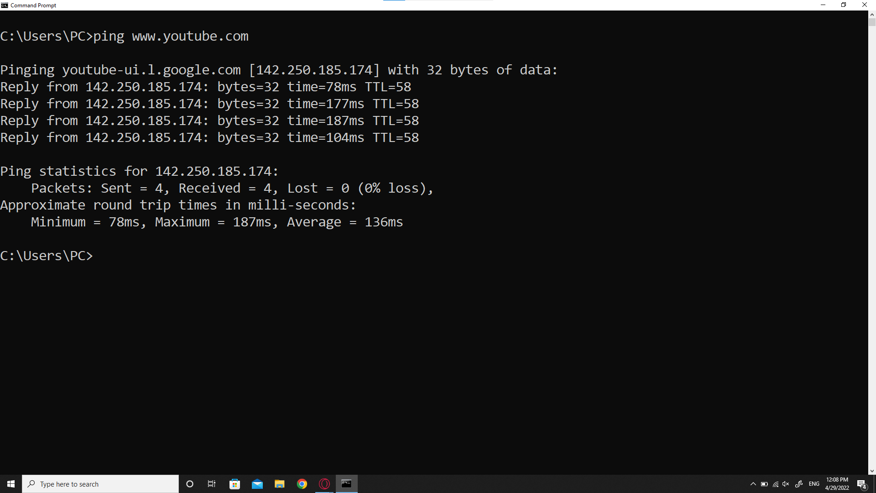

The ping command is used to verify IP-level connectivity to another TCP/IP device by sending Internet Control Message Protocol (ICMP) echo Request messages. If the request did not counter any troubles on its way, a receipt of corresponding echo Reply messages are displayed, along with round-trip times.

In our example we pinged youtube’s official host name. The first thing the command did was find youtube’s IP address which is 142.250.185.174. Then it sent 32 byte of data to the server. Next, it displays the replay messages from the server with its round trip time and TTL.

Then it displays a statistics summary for the whole process where our computer sent 4 packets and 4 packets were sent back from the device with an average round trip of 136ms.

## Tracert [ww.youtube.com](http://www.youtube.com)

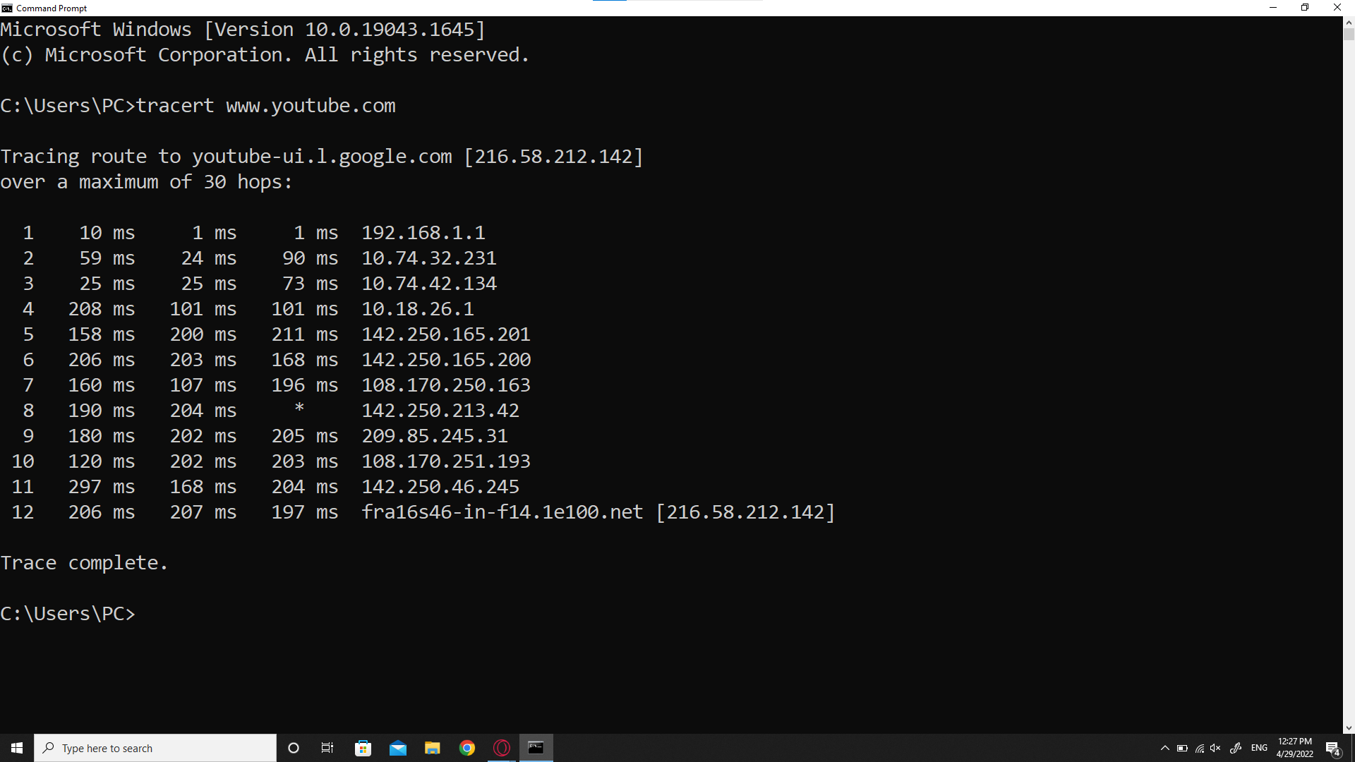

Tracert or Traceroute command is used to determine the path between two connections. Often a connection to another device will have to go through multiple routers. The traceroute command will return the names or IP addresses of all the routers between the two devices along with the round trip time. This also allows us to see where a packet may be misguided.

Tracert usually sends 3 requests.

In our example the command displays each entry or hop the packet passes through to reach its final destination. If the trace times out “*” like what happened with us in number 8 third request, it means there is a problem at that location, or that the route is incorrect, or the router prevented the packet from entering it to reach its destination, so sometimes the packet got lost in the way.

Usually the first hop is to a routing device upstream of the computer. And last one is the destination router.

## Nslookup www.youtube.com

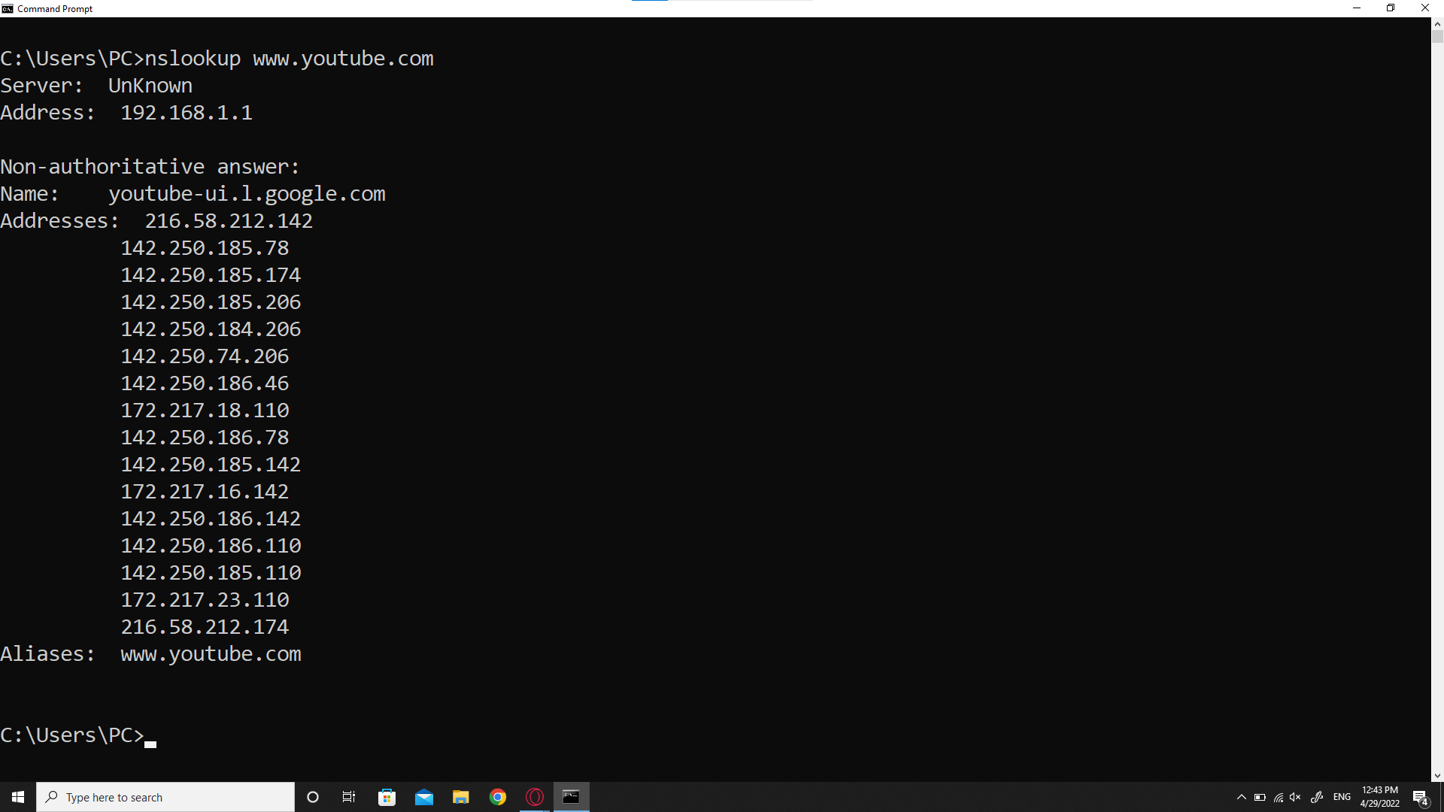

Nslookup is the name of a program that lets an internet server administrator or any computer user enter a host name and find out the corresponding IP address or domain name system(DNS) record.

# Part 2: